3RD ANNUAL HALLOWEEN BOWL
PLEASE FILL OUT FORM AND EMAIL TO development@movesandgrooves.org
BOWLER #2
BOWLER #3
BOWLER #4
TEAM CAPTAIN
BOWLER #5
Bowler’s Name:
Address:
City:
Zip:
Phone:
Company:
State:
Email:
Bowler’s Name:
Address:
City:
Zip:
Phone:
Company:
State:
Email:
Bowler’s Name:
Address:
City:
Zip:
Phone:
Company:
State:
Email:
Bowler’s Name:
Address:
City:
Zip:
Phone:
Company:
State:
Email:
Bowler’s Name:
Address:
City:
Zip:
Phone:
Company:
State:
Email:

Bowler’s Name:
Address:
State:
Email:
Work Phone:
City:
Zip:
Cell Phone:
Participant Info:
- Sign up as many sponsors as you can.
- Collect as many pledges as possible. Great Prizes for the top fundraisers!
- Please print name and addresses clearly.
- Bring your pledge sheet and donations with you for your admissions to the event.
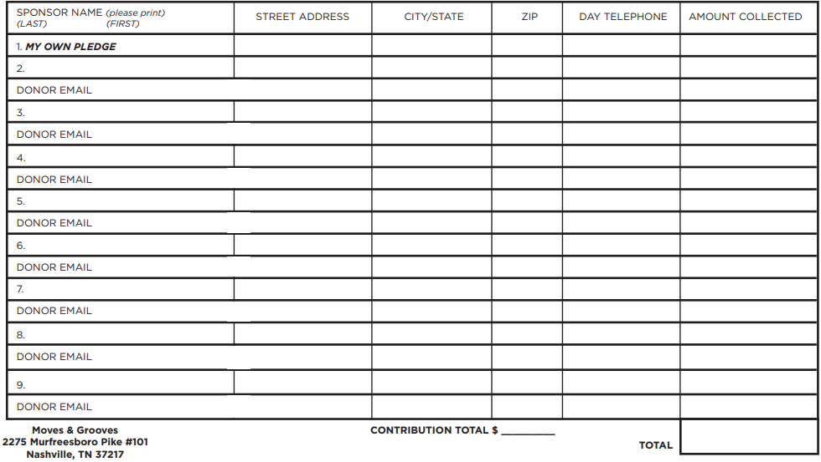
*MINIMUM GOAL PER BOWLER $125

